**Design and Development of a**

**Solar E-Bicycle with an Embedded based**

**Smart Monitoring System**

Report submitted to GITAM (Deemed to be University) as a partial fulfillment of the requirements for the award of the Degree of Bachelor of Technology in (write your respective branch)



DEPARTMENT OF ELECTRICAL, ELECTRONICS AND COMMUNICATION ENGINEERING

GITAM SCHOOL OF TECHNOLOGY

GITAM (DEEMED TO BE UNIVERSITY)

BENGALURU -561203

NOV 2025

**Name :SALOMI S**

**RAKSHITHA N**

**Regd.No. :BU22EECE0200006**

**BU22EECE0200019**

**DECLARATION**

We declare that the project work contained in this report is original and it has been done by me under the guidance of my project guide.

Name:

Date:

**DepartmentofElectrical,ElectronicsandCommunicationEngineering GITAM School of Technology, Bengaluru-561203**



**CERTIFICATE**

This is to certify that Salomi.S And Rakshitha.N bearing BU22EECE0200006 and BU22EECE0200019 has satisfactorily completed MiniProject Entitled in partial fulfillment of the requirements as prescribed by University for VIIth semester, Bachelor of Technology in “Electrical, Electronics and Communication Engineering”and submitted this report during the academic year 2025-2026.

[SignatureoftheGuide] [SignatureofHOD]

**Tableofcontents**

**Chapter1: Introduction 1**

* 1. Overviewoftheproblemstatement1
  2. Objectivesandgoals 1

**Chapter2:Literature Review 2**

**Chapter3:StrategicAnalysisandProblemDefinition 3**

* 1. SWOTAnalysis 3
  2. ProjectPlan-GANTTChart 3
  3. Refinement of problem statement3

**Chapter4:Methodology 4**

* 1. Descriptionoftheapproach 4
  2. Toolsandtechniquesutilized 4
  3. Design considerations 4

**Chapter5:Implementation5**

* 1. Descriptionofhowthe projectwasexecuted 5
  2. Challengesfacedand solutionsimplemented5

**Chapter6:Results6**

* 1. outcome6
  2. Interpretationofresults6
  3. Comparisonwith existing technologies 6

**Chapter7: Conclusion 7**

**Chapter8:FutureWork 8**

**References 9**

**Chapter1:Introduction**

* 1. Overview of the problem statement

Today, people need transportation that is both affordable and eco-friendly. Normal bicycles are good for short trips but require a lot of effort, especially for long distances or uphill rides. On the other hand, fuel-powered vehicles cause pollution, increase fuel expenses, and rely on non-renewable energy.

Electric bicycles solve some of these issues, but they depend on batteries that need frequent charging and electricity from the grid, which is not always clean.

A better option is to use solar energy in electric bicycles. Solar panels can charge the battery using renewable energy, reduce dependence on the power grid, increase travel range, and provide a greener, more practical transport solution for everyday use in cities and towns.

**1.2** Objectivesandgoals

**Objective:**

The main objective of this project is to design and develop a **solar-powered electric bicycle** that can serve as an affordable, eco-friendly, and practical mode of transport. Unlike traditional bicycles, which require continuous manual pedaling, and fuel-based vehicles, which increase pollution and costs, this bicycle aims to combine **renewable energy with electric mobility** to create a more sustainable solution.

The system integrates **solar panels** to harness clean solar energy and charge the bicycle’s battery, reducing dependence on grid electricity and extending the travel range. To enhance user convenience, an **IoT-based dashboard** is incorporated, which provides real-time monitoring of key parameters such as **battery status, speed, distance, and solar charging performance**.

Beyond efficiency, the project emphasizes **smart and safe urban mobility**. By combining solar charging with IoT monitoring, the bicycle supports modern transport needs while promoting environmental sustainability. This design not only addresses the limitations of conventional and electric bicycles but also provides a **scalable and sustainable solution** for urban and semi-urban transportation.

Goals:

**Main Goals**

* Solar + plug-in charging (continuous battery)
* BLDC hub motor drive (efficient & sustainable)
* IoT dashboard (battery, speed, distance, solar status)
* Smartphone connectivity (performance data & alerts)

**Chapter2: LiteratureReview**

Several studies have explored the potential of solar-assisted bicycles and vehicles. T. Suresh (2021) presented techniques for developing solar-powered bicycles, highlighting their role in reducing dependency on conventional energy sources. Similarly, Hema Latha (2019) focused on the design and development of solar-powered vehicles, emphasizing sustainability and efficiency in mobility solutions. More recently, P. Maheswara Rao (2024) implemented practical approaches to solar bicycle design, contributing to advancements in renewable-powered transport. In parallel, Adhisuwignjo (2017) examined e-bike sharing systems, underscoring the importance of integrating smart and accessible transportation models for urban environments.

In terms of technical resources, various guides and datasheets provide essential information for system design. These include BLDC motor and controller specifications, battery management system (BMS) datasheets, and MPPT charge controller documentation. Standards such as IEC 62133, IEEE 1562, and IS guidelines serve as benchmarks to ensure safety, reliability, and performance.

Existing implementations further demonstrate the practical adoption of these systems. Open-source e-bike hardware and software platforms enable customization and scalability, while DIY modular controllers and display units provide flexibility for enthusiasts and developers. Additionally, repositories dedicated to e-bike analytics and instrumentation support data-driven improvements and monitoring, paving the way for smarter and more efficient solar e-bike systems.

**Chapter3:Strategic Analysis and Problem Definition**

* 1. SWOT Analysis

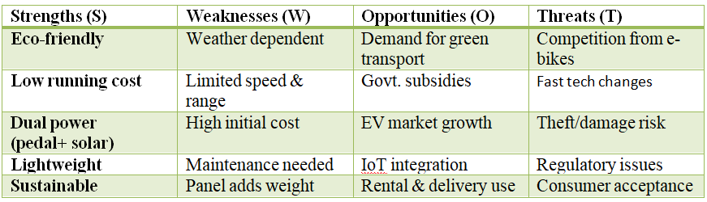

* 1. ProjectPlan-GANTT Chart

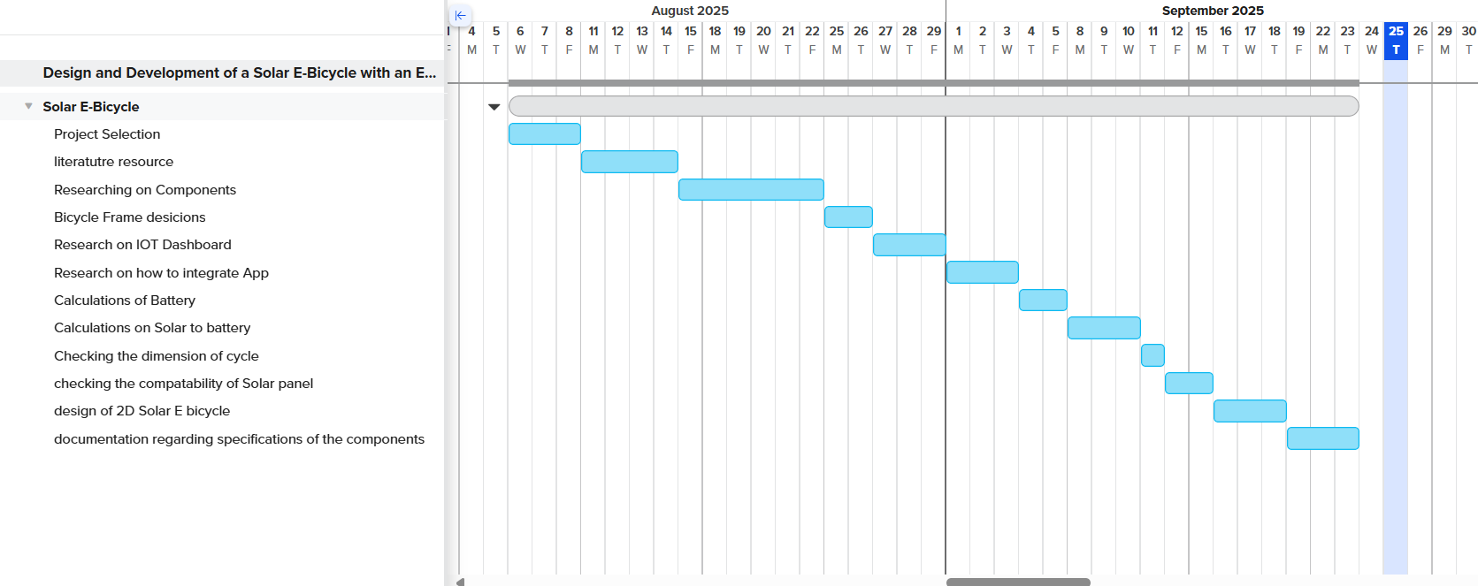

3.3Problemstatement

The rising cost of conventional fuel and increasing environmental pollution have created an urgent need for sustainable and eco-friendly transportation solutions. Traditional bicycles, though environmentally friendly, require significant physical effort and are not practical for longer distances or for users with limited physical capability. Electric bicycles offer convenience but depend heavily on electricity from non-renewable sources and require frequent recharging, which increases cost and environmental impact. Therefore, there is a strong need for a transportation alternative that is both energy-efficient and sustainable. A solar-powered bicycle provides a viable solution by utilizing renewable energy, reducing dependence on fossil fuels, lowering operational costs, and offering an efficient, reliable, and environmentally responsible mode of daily commuting.

**Chapter4 :Methodology**

* 1. Description of the approach

The methodology for developing the solar-powered bicycle follows a systematic and integrated approach combining mechanical design, electrical components, and software monitoring to achieve efficient and sustainable operation.

1. **Selection of Components:**
   * **Solar Panels:** Chosen based on power output, size, and weight to efficiently charge the battery.
   * **Battery:** Selected to store sufficient energy for daily use and to provide backup when sunlight is insufficient.
   * **Motor & Controller:** Motor capacity is matched with battery output for smooth operation, with a controller to regulate speed and power.
2. **Energy Management System:**
   * A charge controller ensures safe and efficient charging of the battery from solar panels.
   * Sensors monitor battery voltage, current, and temperature for optimal performance and safety.
3. **Mechanical Design:**
   * Bicycle frame is modified to accommodate solar panels and battery without affecting stability.
   * Design ensures lightweight construction and rider comfort.
4. **IoT & Software Integration:**
   * IoT-enabled system tracks battery level, speed, and overall performance in real-time.
   * Data is displayed on a dashboard or mobile app for user convenience.
5. **Testing and Calibration:**
   * The complete system is tested under different conditions to check battery performance, motor efficiency, and overall reliability.
   * Adjustments are made to optimize energy efficiency and user safety.

4.2 Tools and techniques utilized

|  |
| --- |
| **1. Brushless DC Hub Motor (BLDC)** |

|  |
| --- |
|  |

|  |
| --- |
| Type : Brushless DC (BLDC) Hub Motor  Voltage rating : 36V  Power rating : 250W |

|  |
| --- |
|  |

|  |
| --- |
|  |

**2**. **BLDC Motor Controller**

|  |
| --- |
| 36V BLDC Motor Controller |

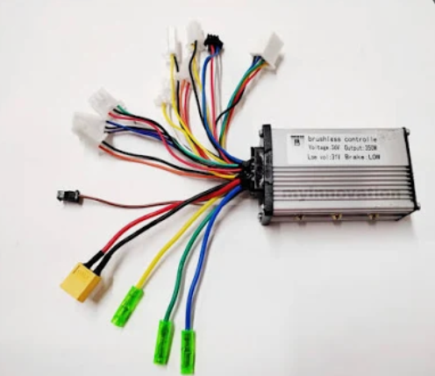

**3. Solar Panel**

|  |
| --- |
| Maximum Power : 50W  Open Circuit Voltage : 22.50V  Short Circuit Current : 2.60A  Voltage at Max Power : 20V  Current at Max Power : 2.5A  Max System Voltage : 600V/1000V  Dimensions (cm) : 66.5x44.5x3.1 |

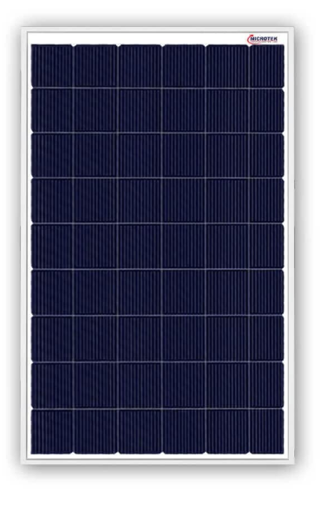

**4. Battery**

|  |
| --- |
| Type : Lithium ion battery  Voltage : 36V  Capacity : 10.4 Ah |

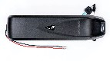

**5.Charger**

|  |
| --- |
| Compatible with 36V battery pack |

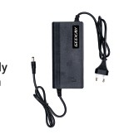

|  |
| --- |
| Model: STM32F103C8T6.  Core: ARM 32 Cortex-M3 CPU.  Debug mode: SWD.  72MHz work frequency.  64K flash memory, 20K SRAM.  2.0-3.6V power, I/O. |

**6. STM32F103C8T6**.

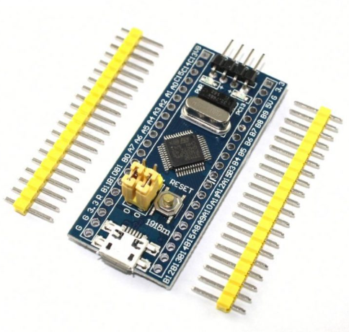

**7. One**[**MicroSD Card module**](http://rover.ebay.com/rover/1/711-53200-19255-0/1?icep_ff3=9&pub=5575122344&toolid=10001&campid=5337793773&customid=&icep_uq=MicroSD&icep_sellerId=&icep_ex_kw=&icep_sortBy=12&icep_catId=&icep_minPrice=&icep_maxPrice=&ipn=psmain&icep_vectorid=229466&kwid=902099&mtid=824&kw=lg)

|  |
| --- |
| Power supply: 4.5V – 5.5V, 3.3V voltage regulator circuit board  Positioning holes: 4 M2 screws positioning hole diameter of 2.2mm  Control Interface: GND, VCC, MISO, MOSI, SCK, CS  Size: 45 x 28mm  Net weight: 6g |

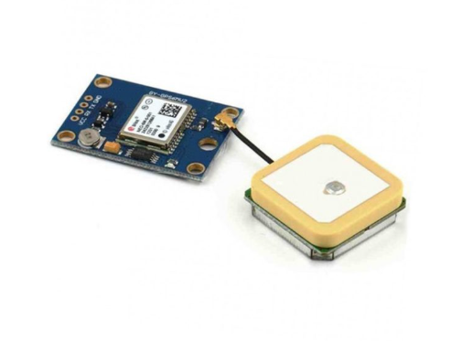

### 8. NX3224T028

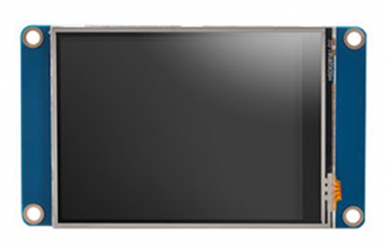

### 

|  |
| --- |
| Standard interface layout, compatible with a variety of Arduinos such as the Pro Mini  Original FTDI FT232 chip, stable performance  USB power has current protection, using 500MA self-restore fuse  RXD/TXD transceiver communication indicator  With power, sending, receiving indicator, working status LED indicators  Mini USB Port Connection |

### 9. 5V USB to TTL

### 

4.3Design considerations

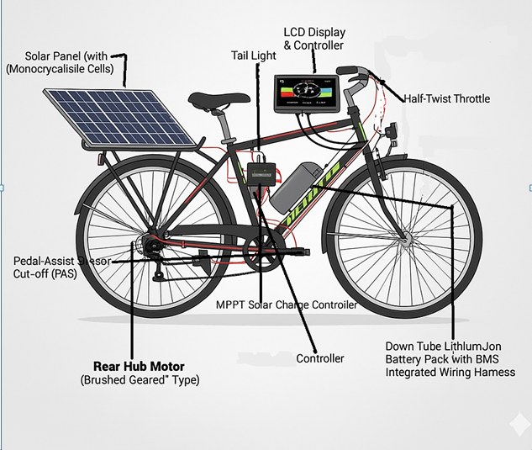

**Chapter5 :Implementation**

* 1. Description of how the project was executed

The solar-powered bicycle project was executed through a systematic approach combining design, assembly, integration, and testing of mechanical, electrical, and software components. The execution process can be described in the following steps:

1. **Component Selection:**
   * Suitable components were selected based on efficiency, compatibility, and cost. These included a 36V 250W BLDC hub motor, a 50W solar panel, MPPT controller, trapezoidal motor controller, STM32 microcontroller, battery, sensors, and LCD for display.
2. **Mechanical Setup:**
   * The bicycle frame was modified to securely mount the solar panel and battery while maintaining balance and rider comfort. Brackets and mounts were fabricated to hold all components in place without affecting the bicycle’s stability.
3. **Electrical Connections:**
   * The solar panel was connected to the MPPT controller to ensure maximum energy harvesting. The output of the controller charged the battery, which in turn powered the BLDC motor via the trapezoidal controller. Wiring and connections were carefully designed to ensure safety, efficiency, and reliability.
4. **Microcontroller and IoT Integration:**
   * The STM32 microcontroller was programmed to read sensor data (battery level, speed, temperature) and display it on the LCD. The system was designed for possible IoT integration to enable real-time monitoring through a mobile app or dashboard.
5. **Testing and Calibration:**
   * The fully assembled system was tested under various conditions to evaluate motor performance, battery efficiency, and solar charging effectiveness. Adjustments were made to the motor controller settings, sensor calibration, and panel positioning to optimize overall performance.
6. **Final Implementation:**
   * After successful testing, the solar-powered bicycle was made fully operational, demonstrating the integration of renewable energy, efficient motor control, and real-time monitoring. The system is now capable of providing eco-friendly and cost-effective transportation for daily use.

5.2 Challenges faced and solutions implemented

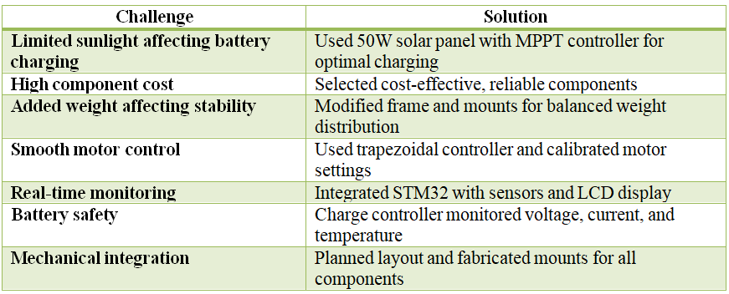

**Chapter6:Results**

* 1. outcomes
  2. Interpretationofresults
  3. Comparisonwith existing literatureor technologies

**Chapter7:Conclusion**

HerewriteSuggestionsforfurtherresearchordevelopmentand Potential improvements or extensions

**Chapter8 :FutureWork**

HerewriteSuggestionsforfurtherresearchordevelopmentPotential improvements or extensions

**References**

Bengaluru City Office No 5/1, First Floor, Prestige Terraces, Union Street, Infantry Road, Bengaluru - 560003 Karnataka, India

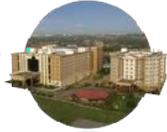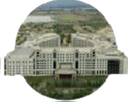

**GIMSR**

GITAM MedicalCollegeRd, GandhiNagar,Rushikonda, Visakhapatnam - 530045 Andhra Pradesh, India